**INSTITUTO POLITÉCNICO NACIONAL**

**ESCUELA SUPERIOR DE CÓMPUTO**

Student: Ortiz Rodríguez Salvador Alejandro

Project: Animation

Professor: Saucedo Delgado Rafael Norman

Group: 3CV8

10/02/2020

Ideas:

My ideas to this animation were:

* Cowboys
* Mafia
* Zombies
* Medieval
* Pirates
* Italian Renaissance
* America’s Conquest
* War
* Independence

In my animation I want to express lots of emotions and feelings, principally emotion about something emotive, hope for some situation, maybe the revenge and the conclution of that in the character’s story, could be a trailer of one topic.

13/02/2020

Story order: **(Trailer)**

1. Show some action scenes with some dialogues of the main character (or another character)
2. Presents a little introduction of the story or the origins of the main character with his voice (flashbacks)
3. The conflict or the purpose of the main character, including the appearance of the bad guys
4. More action scenes with the main character and the bad guys
5. Suspense/Credits/Soon/Etc.

Topic: Mafia

Number of Characters: 13 aprox.

Bad Guys: 5 aprox.

Storia Di Vendetta

This story goes about one man who discovers his purpose in life. This is a story of a man who lost everything and wants vengance, his name is Salvatore Di Alessandri.

Based in a real historical period of time with real characters who lived in the early XX century.

Characters like Joe Profaci (1928-1962) from the Colombo family, Salvatore D’Aquila (1878-1928) from the Gambino family, Lucky Luciano (1931-1946) and Don Vito Genovese (1957-1969) from the Genovese family, one of the most important families in E.U. at that time, Gaetano “Tommy” Reina (1913-1930) from the Lucchese family, among others.

The Italian mob in the United States, better known as "La Cosa Nostra".

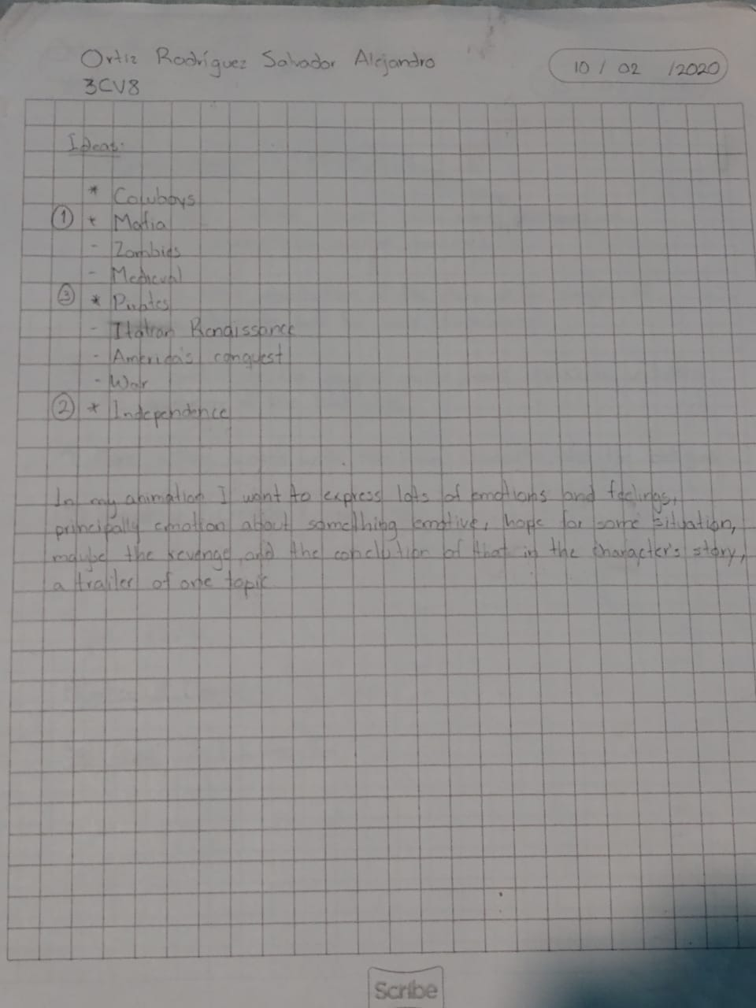

**Breve Historia:**

La familia de Salvatore es traicionada por Gaetano “Tommy” Reina de la familia Lucchese, debido a esto Alfredo, Giovanni, Francesco y Mario Di Alessandri fueron asesinados; el plan consistía en erradicar a la familia Di Alessandri, pero María, Cristina y Salvatore logran escapar. Salvatore jura vengarse contra aquel que le arrebató lo que más amaba, en el camino de su venganza descubre todo un círculo mafioso que busca el control de todo el país y el cómo su familia estaba involucrada de cierto modo en ello.

Gaetano de la familia Lucchese era un supuesto “amigo” de Alfredo (padre de Salvatore). Alfredo le proporcionaba información sobre círculos del crimen (la mafia) a la conveniencia de Gaetano ya que buscaba el dominio absoluto de su familia, utilizando a Alfredo hasta que ya no fue necesario y que éste comenzaba a sospechar.

Alfredo pertenecía a una organización secreta que buscaba el orden y el equilibrio en las sociedades.